
Position # Data Analyst
Location # Islamabad

Candidate Name # ……….
Instructions#
- Make sure to write your name in the document.
- You can write SQL code in any variant, but Postgresql or HiveQL is preferred.
- Please paste the answer script right below the question and send us the document back.

Following are the three Tables which need to be used for questions asked at the end of this document#

- Invoices Table #
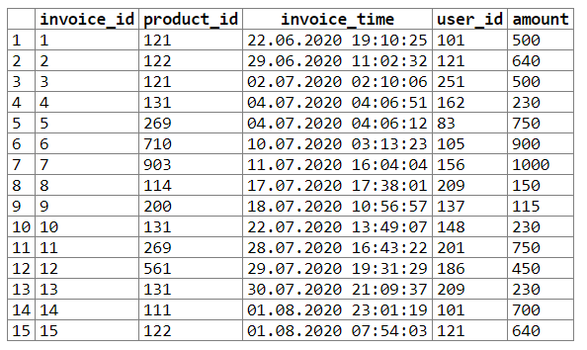
Invoices table contains 4 columns :
1. invoice_id (primary column to indentify an invoice)
2. Product_id (identifies products associated with the invoice, int column)
3. Invoice_time (the exact time when this invoice was generated, timestamp column)
4. User_id (indicates the user against whom the invoice has been generated, int column)
5. Amount (total amount charged against a unique invoice, float column)
- User_Activtiy Table #
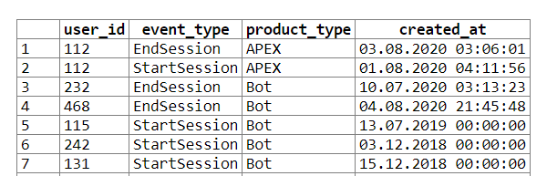
User_Activity table contains 4 columns :
1. User_id (this isn’t unique)
2. event_type (This is based on every event happening in every product, varchar column)
3. Product_type (Multiple product names exist in this column, varchar column)
4. Created_at (Tracks the exact time when an activity occurs in any product, timestamp column)

- Product_Description Table #
Product_Description table contains 2 columns :
1. Id (primary key)
2. desccription (Jsonb type column which contains the complete description of every product)

Questions #
- Write a SQL query to find the minimum sold product (in terms of amount) every year using window functions only.
---------------------------------------Paste SQL Code Here ----------------------------------------------------
- Write a SQL query to find how many products were sold monthly, based on class type of product, in year 2020.
---------------------------------------Paste SQL Code Here ----------------------------------------------------
- Calculate rolling 30 days unique active users for the last 40 days (
Formula # rolling 30 days for today = unique users whose “event_type=StartSession” between today and today-30 days, so you need to calculate for last 40 days like this), from users_activity table.
Note # Make sure the query is optimized. Getting the right output is not the only requirement here.
---------------------------------------Paste SQL Code Here ----------------------------------------------------
- Calculate the month over month retention(through ‘Event type = StartSession’) for Product type = APEX for year 2020
Example (
For Jan = From Jan-2020 active users of APEX, how many are active in Feb,Mar,Apr……..
For Feb = From Feb-2020 active users of APEX, how many are active in Mar,Apr,May…….
.
.
.
Till Jul-2020)
Note # Make sure the query is optimized. Getting the right output is not the only requirement here.
---------------------------------------Paste SQL Code Here ----------------------------------------------------

